**Pottery Shard (145 Alice St.)**

Nora Rhein

During the last day of excavations of 145 Alice St. on October 19th, something distinct appeared in the north half of Unit 4. This artifact found in context AW22, a cream-colored ceramic shard, holds a maker’s mark. While we found approximately 55 pieces of ceramics in our unit during the excavations, this was one of the only shards to have a clear, legible maker’s mark. On the front, the mark reads “CANARYTO”, with “MADE IN U.S.” below it, and the assumed serial number “291A.” Although this artifact only measured 3 cm, it yields so much information. 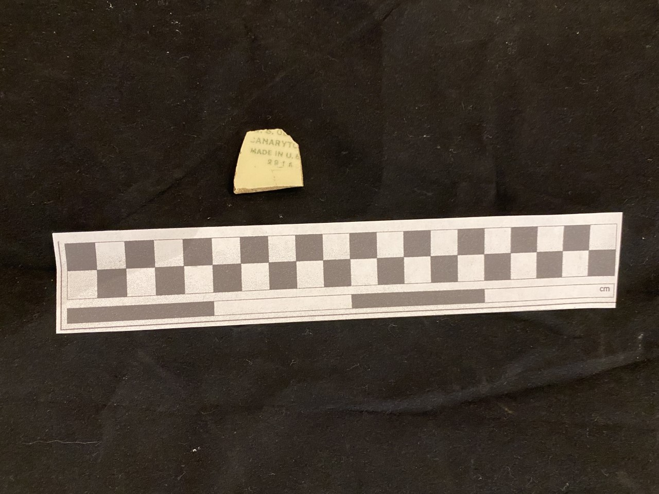

Figure 1: Ceramic shard, Unit 4 AW22

It was assumed from the moment this artifact was discovered that this was some kind of vessel because of the double glaze. We had been finding many other double-glazed ceramics prior to this shard, so we understood the families who lived in this house appreciated nice-looking domestic goods. This vessel would have been no different.

From observation, we were able to determine this maker’s mark belonged to the W.S. George Pottery Company. This company operated out of Ohio and Pennsylvania between the years 1904 to 1960**[1]**, which means this vessel dates back to the first half of the 20th century. The W.S. George Pottery Company produced semi-porcelain dinnerware, hotel wares, and toilet wares. Their products varied by shapes and patterns, carrying over 30 shapes and hundreds of patterns**[2]**. Dinnerware sets, ranging from 4 to 53 piece sets, averaged from $6.95 to $19.95**[3]**. Their maker’s mark varied by decade, shape, and pattern. In the case of our artifact, the mark that it lines up with the most is the same mark stamped on the “Lido” shaped wares. The “Lido” shape supposedly dates back to the 1930’s.

Figure 2: Pottery shard maker’s mark, Unit 4 AW22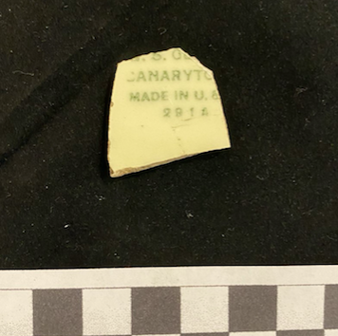

Figure 3: Complete maker’s mark for W.S. George “Lido” shape. Figure 4: W.S. George Lido shape 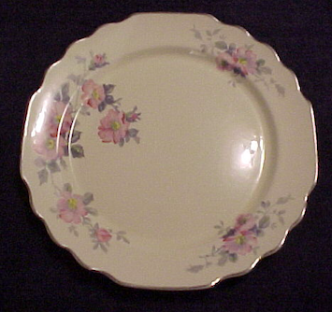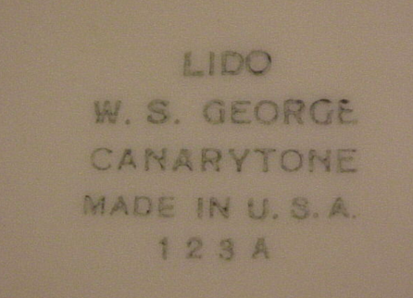

Since we now know about how old this artifact is, where it’s from, what it would have looked like, and the cost of its related products, we can make further interpretations about what it meant to a Hamtramck family. The consumption of material items was a form of class and social status expression in the 19th and 20th centuries, especially for those in the middle class. Although the emerging middle classes had lesser means than the elite, they still sought to set themselves apart with ornamental items (Nassaney, et al. 2001: 248). Ceramics were one of the first, and most popular, household goods to be mass produced on a scale where middle class families would be able to afford them (Ryzewski 2015: 420). There were so many diverse patterns that ceramics could be decorated with, further emphasizing the consumer’s individuality. Economic status usually determined if a family’s ceramics were plain or ornately detailed (Nassaney, et al. 2001: 249). In this case, W.S. George plates were almost always decorated in an elaborate pattern like florals. Judging by what the “Lido” plates usually look like (Figure 4), this artifact reflects an owner who had the means to spend more on detailed ceramics.

Assuming this specific artifact dates back to the 1930s, combined with the fact that the inflation rate for 1930 was around -2.7 %**[4]**, W.S. George’s dinnerware sets would have cost around $80 to $200 in 2020 money. These particular products would’ve been more of an investment than just a purchase, but the mass production of ceramics guaranteed the ability to have quality, beautiful possessions on a working class income. In the case of a 20th century Hamtramck family, manufacturing jobs became the norm, with most of the city’s population employed by the Dodge Main plant (Kowalski 2002: 33). From this analysis, 145 Alice St. may have been a household with a steady semi-expendable income, with the desire to have nice things to set themselves apart in an industrial center like Hamtramck.

**Works Cited**

Figure 3 - Sacksteder. “Shapes.” *W. S. George / E. P. P. Co. Shapes*, 2005, wsgeorge.jdfiles.org/shapes/shapes1.html.

Figure 4 - Sacksteder. “Shapes.” *W. S. George / E. P. P. Co. Shapes*, 2005, wsgeorge.jdfiles.org/shapes/shapes1.html.

Kowalski, Greg. *Hamtramck: the Driven City*. Arcadia Pub., 2002.

Nassaney, et al. 2001. The Southwest Michigan Historic Landscape Project: Exploring Class, Gender, and Ethnicity from the Ground Up. *International Journal of Historical Archaeology.*  5(3): 219-261

Ryzewski, Krysta 2015. “‘No Home for the Ordinary Gamut’: A Historical Archaeology of Community Displacement and the Creation of Detroit, City Beautiful,” *Journal of Social Archaeology,* 15(3): 408-431.

1. Sacksteder. “W.S. George Pottery Company.” *The W. S. George Pottery Company*, 2005, wsgeorge.jdfiles.org/index.html.
2. Sacksteder. “Shapes.” *W. S. George / E. P. P. Co. Shapes*, 2005, wsgeorge.jdfiles.org/shapes/shapes1.html.
3. Sacksteder. “Facts.” *Other W. S. George Facts*, 2005, wsgeorge.jdfiles.org/facts/facts.htm.
4. “Consumer Price Index, 1913.” *Federal Reserve Bank of Minneapolis*, 2020, www.minneapolisfed.org/about-us/monetary-policy/inflation-calculator/consumer-price-index-1913-.